Year 11 – Periodic Trends
Watch, answer Qs and take notes: https://www.youtube.com/watch?v=hePb00CqvP0
- What is a line going horizontally on the periodic table called?

- What is a line going vertically on the periodic table called?

- How were the elements arranged in the table?

- What are the 3 types of elements mentioned?

Extra notes:

- Why do elements in the same group behave similarly?

- What are valence electrons?

- What is the first trend identified in the video?

- What is the trend down the table?

- What is the trend across the table to the right and what causes it? (Key words: atomic radius, proton, electromagnetic attraction, electron shells)

- Write the overall atomic radius trend seen on the table?

Extra notes:

- Is Ionic radius the same as atomic radius? What is it?

- Electrons repel each other so what happens when an electron is added?

- What happens when an electron is removed?

- What happens to Ions with the same electron configuration as the atomic number increases?

Extra notes/examples:
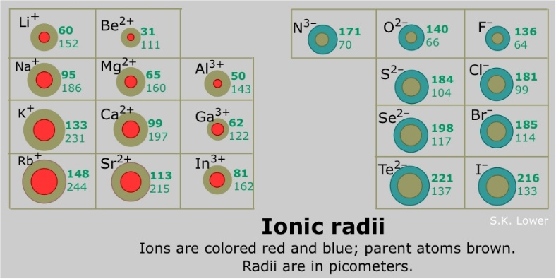

Activity:
- Describe and draw the relative atomic radii of Na, Mg, Al, Si, Cl.

- Compare and contrast: K, Gr and Ba. (Be sure to mention positioning in the periodic table, atomic radii, valences, ionisation and ionic radii)

Home work is to revise and explore: http://www.rsc.org/periodic-table
Use this to write up study notes using success criteria as a guide
- What is electronegativity?

- Write the trend of electronegativity seen on the Periodic table?

- Why does it increase up and right?

- Which elements do we disregard for this trend and why?

- What is ionisation energy?

- Bonus Q: What are the units for energy?

- The electromagnetic force that attracts electrons to the nucleus drops off the further away it is. Q: The further away from the nucleus that an electron is the____________ it is to remove.

- Write the ionisation energy trend seen on the Periodic table:

Extra Notes:

NB: Atoms like to have their outer most shell completely full

